Experiment 1: Create a Simple Cloud Software Application as a SaaS
Aim
To create a simple cloud-based SaaS application using Zoho Creator for managing student leave requests online.
Software Used
- Zoho Creator
- Web Browser (Chrome/Edge)
- Internet Connection
Algorithm
- Login to Zoho Creator.
- Create a new application.
- Create a Student Registration form.
- Create a Leave Request form.
- Add required fields to both forms.
- Create reports for submitted leave requests.
- Publish the application.
- Test data entry and report generation.
Output:
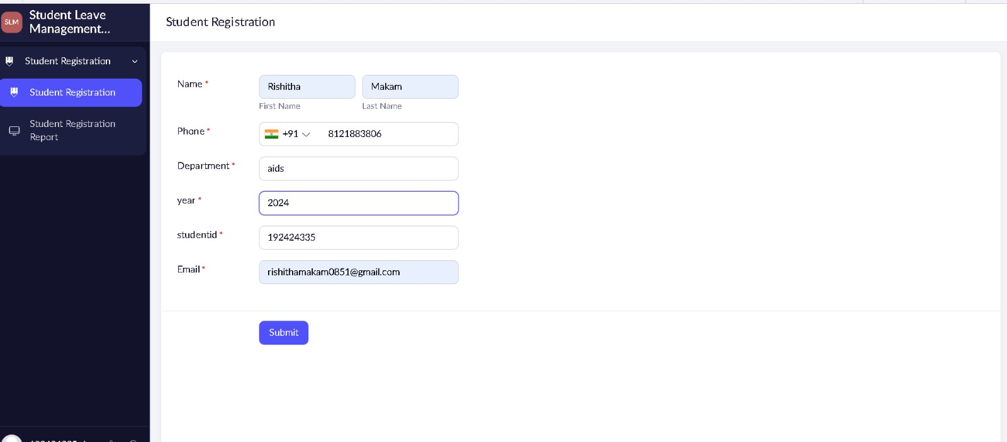
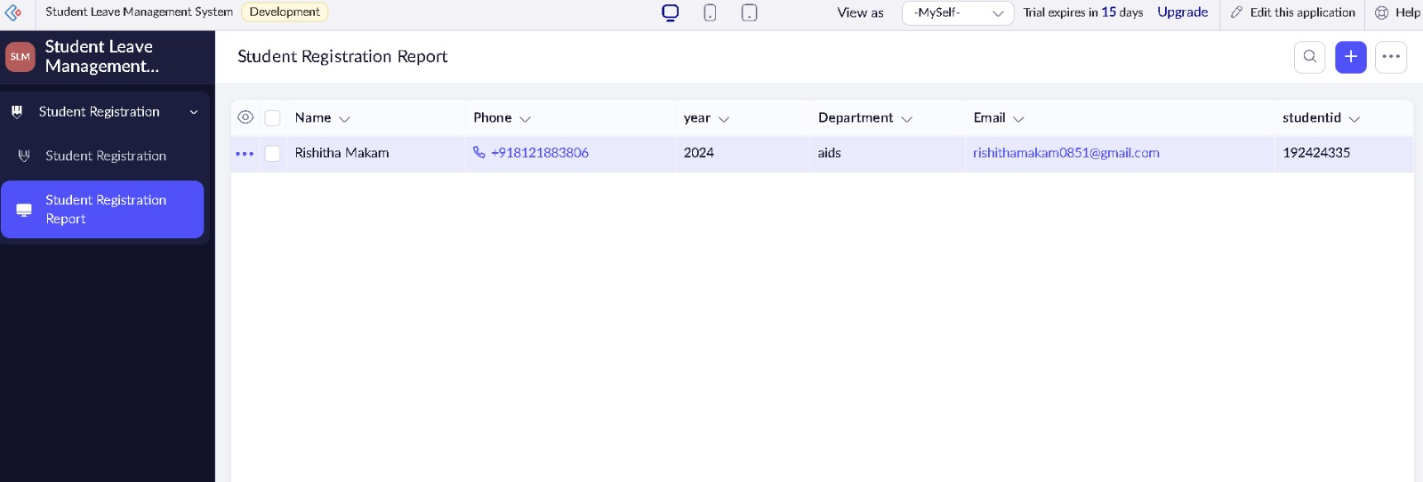
Result
A cloud-based Student Leave Management SaaS application was successfully developed and tested in Zoho Creator.

